Danieli Inventory of Multigenerational Legacies of Trauma©

Items, Instructions, and Publications

Yael Danieli¹

Fran H. Norris

Copyright, Yael Danieli, 2015.
Corresponding author: Yael Danieli, Director, Group Project for Holocaust Survivors and their Children. 345 East 80th Street (31-J). New York, NY 10075. E-mail: yaeld@aol.com.

Most recent update: May 21, 2019.

Danieli Inventory of Multigenerational Legacies of Trauma

Part I. Parents’ Posttrauma Adaptational Styles

All items are answered on a 5-point Likert scale: strongly disagree = 1, disagree = 2, neither way = 3, agree = 4, strongly agree = 5.
Randomized item # | Item | Scale | Original item #
1 | Privacy was not allowed (mother/father) | V | 16
2 | Weakness was not tolerated in our home (mother/father) | N | 31
3 | Other than with family members, we socialized almost entirely with other survivors from my parent's original community (mother/father) | F | 30
4 | The Holocaust/genocide/war ª was always present in the house (mother/father) | V | 8
5 | Affection and open expression of love were rare in our home (mother/father) | N | 7
6 | My parents' house was always stocked with food (mother/father) | F | 12
7 | Our social life included only immediate family (mother/father) | V | 20
8 | Closeness was rare (mother/father) | N | 36
9 | I was taught to honor and remember the history of my/our people (mother/father) | F | 32
10 | My mother/father wanted to know where I was at all times | V | 27
11 | Compared to other mother/fathers, my mother/father seemed older than she/he actually was | V | 29
12 | My mother/father avoided watching/reading/listening to ª anything related her/his traumatic experience | N | 46
13 | In our family, feelings of distress were not to be admitted (mother/father) | N | 44
14 | My mother/father often screamed in order to feel heard | V | 11
15 | My mother/father used shame to control my behavior | V | 23
16 | My mother/father often told me how important I was to her/him/them REVERSED | N | 42
17 | Family members were overly protective of one another (mother/father) | V | 3
18 | My parents often seemed disappointed in each other (mother/father) | V | 53
19 | My parents did not feel that justice for their suffering was really done (mother/father) | V | 15
20 | My mother/father always ate very quickly as though the food would disappear | V | 34
21 | I was expected to achieve career and financial success (mother/father) | F | 37
22 | My mother/father seemed frozen in time | V | 1
23 | In our family, the Holocaust/genocide/war ª was never mentioned (mother/father) | N | 54
24 | My mother/father often woke up screaming from nightmares in the middle of the night | V | 19
25 | My mother/father might erupt in violent outbursts, then weep with regret | V | 41
26 | My mother/father never discussed her/his Holocaust/genocide/war ª experiences | N | 5
27 | Open communication seemed not to exist in our home (mother/father) | N | 66
28 | Listening to our traditional music made my mother/father sad | V | 40
29 | My mother/father often told me she/he loved me REVERSED | N | 22
30 | My parents' marriage was primarily based on factors other than love (mother/father) | V | 17
31 | My mother/father did not believe in G-d^{b} after the Holocaust/genocide/war ª REVERSED | F | 68
32 | Our home was devoid of emotions (mother/father) | N | 61
33 | My mother/father's behavior sometimes terrified me | V | 59
34 | It felt dangerous to express emotions at home (mother/father) | N | 39
35 | At times, my mother/father would suddenly look as if she/he were far away | V | 33
36 | My mother/father reacted in a catastrophic way to even minor changes | V | 9
37 | My mother/father repeated her/his Holocaust/genocide/war ª stories over and over again REVERSED | N | 43
38 | I was taught to fight against injustice (mother/father) | F | 62
39 | My mother/father seemed strange when compared to other mother/fathers | V | 65
40 | The continued safety of Israel/Ireland/Armenia ª is a major concern in our family (mother/father) | F | 21
41 | Independence was highly valued in our household (mother/father) REVERSED | V | 57
42 | My mother/father worried about everything | V | 50
43 | I never knew which of my questions/comments would upset my mother/father so I chose to not speak my mind | N | 70
44 | Our home was full of sadness (mother/father) | V | 26
45 | In our home, even the smallest decision had to be carefully considered (mother/father) | V | 35
46 | My mother/father taught me to be ready for anything that might happen in life | F | 24
47 | Self-pity was considered a weakness (mother/father) | N | 64
48 | I was taught to mistrust authority (mother/father) | V | 48
49 | I was taught to stand up to authority (mother/father) | F | 63
50 | My mother/father did not give me any guidance | N | 67
51 | It was very difficult for my mother/father to provide reasonable limits | V | 6
52 | Humor was present even when things were difficult (mother/father) REVERSED | N | 47
53 | My mother/father viewed marrying outside the faith/group/race/ethnic/social group ª as a betrayal | F | 25
54 | Family members were overly involved in each other’s lives (mother/father) | V | 55
55 | My mother/father was uncomfortable when interacting with others outside the family | V | 38
56 | My mother/father wouldn’t buy German/British/Turkish ª goods REVERSED | F | 60
57 | I was taught that people should never forget crimes committed against humanity (mother/father) | F | 18
58 | My mother/father felt down on ethnic/religious ª holidays | V | 10
59 | While we were praised for achievements, there was little sense of intimacy in the family (mother/father) | N | 58
60 | My mother/father used guilt to control my behavior | V | 14
Scale key: V = Victim, N = Numb, F = Fighter. This is for the researcher’s reference only.

Part II. Reparative Adaptational Impacts

All items are answered on a 5-point Likert scale: strongly disagree = 1, disagree = 2, neither way = 3, agree = 4, strongly agree = 5.
Randomized item # | Item | Original item #
1 | Sometimes I felt I had to fill in for murdered family members | 49
2 | I find it uncomfortable to be in a position of authority | 34
3 | Most days I wake up looking forward to life REVERSED | 41
4 | It is very hard for me to just relax | 14
5 | I feel drawn to the stories of other children of survivors | 3
6 | I find it difficult to say goodbye | 51
7 | I feel responsible for my parent's/s' happiness | 12
8 | I find it difficult to delegate responsibility to others | 28
9 | Even when successful, I feel forlorn | 17
10 | I felt cheated when I found out my family’s history from others | 56
11 | I think of my parents as vulnerable | 53
12 | I worry that others will look down on me | 9
13 | My peers’ concerns often seemed frivolous to me | 25
14 | I am afraid to imagine what led to my parent's/s' numbness | 30
15 | I often rely on my parent(s) to rescue me financially | 4
16 | I watch Holocaust/genocide/war...-related films and documentaries incessantly | 18
17 | I had to seek guidance outside the family about how to live my life | 22
18 | I have often resorted to alcohol, substance abuse, sex or food to soothe myself | 38
19 | I am very sensitive to being labeled | 19
20 | I fear(ed) bringing children into a world | 24
21 | Contentment is a foreign concept to me | 43
22 | Sometimes I felt overwhelming despair when I didn't live up to my parent's/s' expectations | 27
23 | My first reaction to a new task is, “I can’t…” | 5
24 | I test my ability to survive by continuously taking risks | 39
25 | The culture of the society we live in does not encourage expression of emotions | 45
26 | I have sometimes felt a need to make up for my family's losses | 32
27 | I did my best not to burden my parent(s) with my own problems/issues | 26
28 | In my fantasies, I would have never survived what my parent(s) had gone through | 50
29 | When there is illness in the house, I feel it is my responsibility to make sure that every detail is taken care of | 52
30 | It is important for me to feel powerful | 16
31 | I am very sensitive to being criticized | 29
32 | It is important to me to be in total control | 57
33 | I often experience physical pain (headache, backache, etc.) when I feel difficult, stressful emotions | 13
34 | I expect people to take advantage of me | 44
35 | I am obsessed with watching and reading everything about my parent's/s' experiences | 48
36 | I would feel I had betrayed my family and myself if didn't respond to any negative remark about my faith/group/race/ethnic/social group | 37

Part III. Four Generation Family History and Demographics

Preliminary Questions/Participant Status (these questions precede Part I)

- On the basis of their (a) experiences during the Holocaust (genocide/war) and/or (b) years and places of birth, who among the following are/were survivors?
  - Your mother (yes/no)
  - Your father (yes/no)
  - Your mother’s mother (your maternal grandmother) (yes/no)
  - Your mother’s father (your maternal grandfather) (yes/no)
  - Your father’s mother (your paternal grandmother) (yes/no)
  - Your father’s father (your paternal grandfather) (yes/no)
  - Yourself (yes/no)
- What is your gender? (male/female)
- In what year were you born? _________
- In what country were you born?
Europe, please specify __________
United States
Canada
Israel
Other, please specify ____________
- In what country do you live now?
Europe, please specify __________
United States
Canada
Israel
Other, please specify __________
The remaining questions follow Part II.

Family size, composition, survivorship and loss

Please provide the following information about listed family members:

Your mother
- In what year was your mother born? _______
- In what country was she born? ____________
- Was she living in 1938? (yes/no)
  - If yes to #8, was she living in 1945? (yes/no)
    - If yes to #8a, is your mother living now? (yes/no)
  - If no to #8, was her death the result of the Holocaust? (yes/no)

Your father
- In what year was your father born? ________
- In what country was he born? ____________
- Was he living in 1938? (yes/no)
  - If yes to #11, was he living in 1945? (yes/no)
    - If yes to #11a, is your father still living? (yes/no)
  - If no to #11, was his death the result of the Holocaust? (yes/no)
Your own brothers/sisters, including half-brothers and sisters
- How many brothers and sisters do/did you have?(if the answer is 0, SKIP TO #14)
- Were any of your own brothers and sisters, including half-brothers and sisters, born before/living in 1938? (yes/no)
  - If yes to #13, how many of them were living in 1945?
  - If yes to #13, how many of them were no longer living in 1945?
    - Of those who died, how many died as a result of the Holocaust?

Your mother’s mother (maternal grandmother)
- Was she living in 1938? (yes/no)
  - If yes to #14, was she living in 1945? (yes/no)
    - If no to #14a, was her death the result of the Holocaust? (yes/no)

Mother’s father (maternal grandfather)
- Was he living in 1938? (yes/no)
  - If yes to #15, was he living in 1945? (yes/no)
    - If no to #15a, was his death the result of the Holocaust? (yes/no)

Father’s mother (paternal grandmother)
- Was she living in 1938? (yes/no)
  - If yes to #16, as she living in 1945? (yes/no)
    - If no to #16a, was her death the result of the Holocaust? (yes/no)

Father’s father (paternal grandfather)
- Was he living in 1938? (yes/no)
  - If yes to #17, was he living in 1945? (yes/no)
    - If no to #17a, was his death the result of the Holocaust? (yes/no)

Your aunts and uncles
- Were any of your mother’s (father’s) brothers/sisters born before/living in 1938? (yes/no)
  - If yes to #18, how many of these brothers/sisters were living in 1945?
  - If yes to #18, how many of them were no longer living in 1945?
    - Of those who died, how many died as a result of the Holocaust?

The next questions are about experiences your mother had during and after the Holocaust.

- Was your mother ever placed in a ghetto? (yes/no)
  - If yes to #19, please estimate: beginning year _________
  - If yes to #19, please estimate: ending year __________
- Was your mother ever interned in a labor camp or camps? (yes/no)
  - If yes to #20, please estimate: beginning year _________
  - If yes to #20, please estimate: ending year __________
- Was your mother ever interned in a concentration camp or camps? (yes/no)
  - If yes to #21, please estimate: beginning year _________
  - If yes to #21, please estimate: ending year __________
- Was she forced to participate in a death march? (yes/no)
- Did your mother survive in hiding? (yes/no)
  - If yes to #23, please estimate: beginning year _________
  - If yes to #23, please estimate: ending year __________
- Did your mother escape? (yes/no)
  - If yes to #24, in what year did she escape (your best estimate)? __________
- Did your mother participate in the resistance? (yes/no)
  - If yes to #25, please estimate: beginning year _________
  - If yes to #25, please estimate: ending year __________
- Did your mother have other experiences in the Holocaust? (yes/no)
  - If yes to #26, what were those experiences? ____________________________
- Did your mother stay in a displaced person camp? (yes/no)
  - If yes to #27, for how long?
Less than 6 months
6 months to 1 year
More than 1 year)
- Did your mother require hospitalization upon liberation? (yes/no)
- In what country did your mother permanently settle after the war?
Europe, please specify __________
United States
Canada
Israel
Other, please specify __________

- In subsequent years, did your mother have affiliations with formal Holocaust survivor groups (yes/no)?
- Affiliations with general Jewish organizations? (yes/no)
- Informal affiliations (friendships) with Holocaust survivors? (yes/no)

The next questions are about experiences your father had during and after the Holocaust.

- Was your father ever placed in a ghetto? (yes/no)
  - If yes to #33, please estimate: beginning year _________
  - If yes to #33, please estimate: ending year __________
- Was your father ever interned in a labor camp or camps? (yes/no)
  - If yes to #34, please estimate: beginning year _________
  - If yes to #34, please estimate: ending year __________
- Was your father ever interned in a concentration camp or camps? (yes/no)
  - If yes to #35, please estimate: beginning year _________
  - If yes to #35, please estimate: ending year __________
- Was he forced to participate in a death march? (yes/no)
- Did your father survive in hiding? (yes/no)
  - If yes to #37, please estimate: beginning year _________
  - If yes to #37, please estimate: ending year __________
- Did your father escape? (yes/no)
  - If yes to #38, in what year did she escape (your best estimate)? __________
- Did your father participate in the resistance? (yes/no)
  - If yes to #39, please estimate: beginning year _________
  - If yes to #39, please estimate: ending year __________
- Did your father have other experiences in the Holocaust? (yes/no)
  - If yes to #40, what were those experiences? ____________________________
- Did your father stay in a displaced person camp? (yes/no)
  - If yes to #41, for how long?
Less than 6 months
6 months to 1 year
More than 1 year)
- Did your father require hospitalization upon liberation? (yes/no)
- In what country did your father permanently settle after the war?
Europe, please specify __________
United States
Canada
Israel
Other, please specify __________
- In subsequent years, did your father have affiliations with formal Holocaust survivor groups (yes/no)?
- Affiliations with general Jewish organizations? (yes/no)
- Informal affiliations (friendships) with Holocaust survivors? (yes/no)

Other family Information

Parents’ marriage

- In what year did your parents marry? _______
- Did they subsequently either divorce or separate permanently? (yes/no)
  - If yes to #48, in what year did they divorce or separate permanently (best estimate)? ________
  - If yes to #48, did your mother remarry? (yes/no)
  - If yes to #48, did your father remarry? (yes/no)
- Was this your mother’s first marriage? (yes/no) IF YES, SKIP TO #50.
  - In what year did she marry the first time (best estimate)? ______
  - If she was married in 1938 or before, did her first husband survive the Holocaust? (yes/no)
  - How many children did she have from that marriage?
    - If > 0, how many children were born in 1938 or before?
      - If > 0 to # 49c i: How many of these children survived the Holocaust?
      - If > 0 to #49c i: How many of these children did not survive the Holocaust?
- Was this your father’s first marriage? (yes/no) IF YES, SKIP TO #51.
  - In what year did he marry the first time (best estimate)? ______
  - If he was married in 1938 or before, did his first wife survive the Holocaust? (yes/no)
  - How many children did he have from that marriage?
    - If > 0, how many children were born in 1938 or before?
      - If > 0 to # 50c i: How many of these children survived the Holocaust?
      - If > 0 to #50c i: How many of these children did not survive the Holocaust?

Ethnicity and Religion

- Which of the following options best describes your mother’s religious affiliation and practice?
Not Jewish
Secular, ethnic only
Secular, traditional
Observant, traditional
Observant, Orthodox
- Which of the following options best describes your mother’s PARENTS’ religious affiliation and practice?
Not Jewish
Secular, ethnic only
Secular, traditional
Observant, traditional
Observant, Orthodox
- Which of the following options best describes your father’s religious affiliation and practice?
Not Jewish
Secular, ethnic only
Secular, traditional
Observant, traditional
Observant, Orthodox
- Which of the following options best describes your father’s PARENTS’ religious affiliation and practice?
Not Jewish
Secular, ethnic only
Secular, traditional
Observant, traditional
Observant, Orthodox

Education/Occupation/Socioeconomic Status
- What was the highest year of education your mother achieved?
Less than high school or equivalent
High school or equivalent
Some college or post-secondary vocational training
College degree
Post-graduate degree

- If less than high school or equivalent, how many years of school did your mother have? ____

- Which of the following statements best describes your mother’s education
All of her schooling occurred before the Holocaust
All of her schooling occurred after the Holocaust
Some occurred before, some occurred after

- What was the highest year of education your father achieved?
Less than high school or equivalent
High school or equivalent
Some college or post-secondary vocational training
College degree
Post-graduate degree

a. If less than high school or equivalent, how many years of school did your father have? ____

- Which of the following statements best describes your father’s education
All of his schooling occurred before the Holocaust
All of his schooling occurred after the Holocaust
Some occurred before, some occurred after

- What was your mother’s occupation BEFORE the Holocaust? _____________
- What was your mother’s occupation AFTER the Holocaust? _______________
- Which of the following statements best describes how your mother made a living?
The way she made a living was generally the same before and after the Holocaust
The way she made a living changed substantially after the Holocaust
She did not work (outside the home) either before or after the Holocaust
She did not work before the Holocaust but did work after
She did not work after the Holocaust but did work before
- What was your father’s occupation BEFORE the Holocaust? _____________
- What was your father’s occupation AFTER the Holocaust? _______________
- Which of the following statements best describes how your father made a living?
The way he made a living was generally the same before and after the Holocaust
The way he made a living changed substantially after the Holocaust
He did not work (outside the home) either before or after the Holocaust
He did not work before the Holocaust but did work after
He did not work after the Holocaust but did work before

- Which statement best describes your family’s socioeconomic situation before the Holocaust?
Relatively poor, financially struggling, lower class, working class
About average, neither rich nor poor, middle class
Relatively affluent, financially secure but not wealthy, upper middle class
Quite affluent, could afford luxuries, high class

- Which statement best describes you family’s socioeconomic situation after the Holocaust?
Relatively poor, financially struggling, lower class, working class
About average, neither rich nor poor, middle class
Relatively affluent, financially secure but not wealthy, upper middle class
Quite affluent, could afford luxuries, high class

Activities

- How did your mother spend her free time? (check all that apply)
  - Socializing with friends, including playing card/games
  - Arts and crafts, creative activities, including cooking/baking for pleasure
  - Attending performances, such as theatre, films, concerts
  - Participating in sports and other physical activities
  - Following sports
  - Knowledge seeking, taking classes
  - Reading for pleasure
  - Watching television
  - Gardening
  - Other, please specify _______________________________

- How much did your mother value/enjoy her free-time activities?
Not very much, just passing time
A moderate amount, the same as most people
A lot, they were very important to her self-concept or meaning in life
- Did she have interests before the Holocaust that she no longer pursued after the Holocaust? (yes/no/not applicable)

- How did your father spend his free time? (check all that apply)
  - Socializing with friends, including playing card/games
  - Arts and crafts, creative activities, including cooking/baking for pleasure
  - Attending performances, such as theatre, films, concerts
  - Participating in sports and other physical activities
  - Following sports
  - Knowledge seeking, taking classes
  - Reading for pleasure
  - Watching television
  - Gardening
  - Other, please specify _______________________________
- How much did your father value/enjoy his free-time activities?
Not very much, just passing time
A moderate amount, the same as most people
A lot, they were very important to his self-concept or meaning in life
- Did he have interests before the Holocaust that he no longer pursued after the Holocaust? (yes/no/not applicable)

Generational Linkages

- I rarely think of my parent’s parents as my own grandparents
Strongly disagree
Disagree
Neither way
Agree
Strongly agree
- I remember my (grand)parents'/'s Holocaust/genocide/war experiences ‘only in bits and pieces.’
Strongly disagree
Disagree
Neither way
Agree
Strongly agree

Information about yourself

- Were you named after a family member? (yes/no)
  - If yes to #75, what was that person’s relationship to you? (check all that apply)
    - Mother/father
    - Maternal grandmother/grandfather
    - Paternal grandmother/grandfather
    - Aunt/uncle
    - Other, please specify _______________________
  - If yes to #75, was a family member for whom you were named killed in the Holocaust? (yes/no)

- Which of the following best describes your birth order?
Only child
Oldest child
Youngest child
Middle child
- What is your present marital status?
Never married
Currently married/partnered (first marriage)
Currently married/partnered (second marriage or more)
Divorced or permanently separated
Widowed
- Do/did you have children? (yes/no)
  - If yes to #78, how many (including all living or deceased offspring)? _______
  - Were any of your own children named after a family member? (yes/no)
    - If yes to #78b, what was that person’s relationship to you? (check all that apply)
      - Your mother/father
      - Your maternal grandmother/grandfather
      - Your paternal grandmother/grandfather
      - Your sister/brother
      - Your aunt/uncle
      - Your husband’s (child’s father’s) mother/father
      - Your husband’s maternal grandmother/grandfather
      - Your husband’s paternal grandmother/grandfather
      - Your husband’s sister/brother
      - Your husband’s aunt/uncle
      - Other, please specify _______________________
    - If yes to #78b, was a family member for whom your child was named killed in the Holocaust? (yes/no)

- Which of the following options best describes your present religious affiliation and practice?
Not Jewish
Secular, ethnic only
Secular, traditional
Observant, traditional
Observant, Orthodox

- Do you presently have affiliations with formal children (grandchildren) of survivor groups? (yes/no)
- Affiliations with general Jewish organizations? (yes/no)
- Informal affiliations (friendships) with children or grandchildren of Holocaust survivors? (yes/no)

- What was the highest year of education you achieved?
0-6 years
7-11 years
High school
Some college or post-secondary vocational training
College degree
Post-graduate degree

a. If less than high school or equivalent, how many years of school did you have? ____

- What is your present employment status?
Working full time
Working part time
Not working, retired
Not working, disabled
Not working, student
Not working, looking for or unable to find work

- Which of the following best describes your current occupation/profession? If retired, disabled, or not employed but seeking work, please answer according to your last paid job.
1. Management (e.g. managers of: operations, marketing, public relations, human resources, advertising, finance, hotels, restaurants, etc.)
2. Office/Administrative Support (e.g. financial/billing/file/mail clerk, bookkeeper, teller, receptionist, administrative assistant, data entry processor, library assistant, legal secretary)
3. Business and Financial Operations (e.g. financial specialist, budget analyst, event planner, agent, buyer, claims adjuster, real estate assessor, human resources specialist, accountant)
4. Architecture/Engineering (e.g. architect, landscape architect, surveyor, cartographer, engineer, drafter)
5. Art and Design (e.g. fine artist, animator, graphic/floral/interior designer, multimedia artist, set/exhibit designer, art director)
6. Entertainer/Performer (e.g. actor, producer, director, musician, dancer, athlete, coach)
7. Media and Communications (e.g. writer, editor, reporter, announcer, interpreter, media equipment technician, photographer, film/video/TV operator, public relations specialist)
8. Computer/Mathematical (e.g. computer programmer, network/database administrator, mathematician, statistician, software/web developer, user support)
9. Farming/Fishing/Forestry Worker (e.g. farm/greenhouse/fishing/forestry worker, agricultural inspector)
10. Building and Grounds Cleaning and Maintenance (e.g. landscaper, tree-trimmer, building cleaner, janitor, pest control)
11. Life Science (e.g. biologist, ecologist, zoologist, biochemist, conservation/plant/soil scientist, forester)
12. Physical Science (e.g. physicist, chemist, astronomer, hydrologist, geoscientist)
13. Military and Protective Service (e.g. military officer, infantry, police officer, firefighter, security guard, lifeguard, ski patrol, animal control, game warden)
14. Healthcare Practitioner or Technician (e.g. physician, nurse, veterinarian, physical/occupational/recreational therapist, nutritionist, EMT, laboratory technician)
15. Healthcare Support (e.g. medical/dental/veterinary assistant, massage therapist, home health aide)
16. Community and Social Service (e.g. mental health counselor, social worker, guidance counselor, clergy, health educator, probation officer)
17. Social Science (e.g. clinical/counseling/school psychologist, economist, survey researcher, anthropologist, sociologist, historian, political scientist, regional planner)
18. Legal Occupations (e.g. lawyer, legal assistant, paralegal, title examiner)
19. Education/Training/Library (e.g. teacher, adult educator, teaching assistant, librarian, curator, archivist)
20. Transportation (e.g. truck/bus/taxi/ambulance driver, material mover, sailor, pilot, flight attendant, railway worker)
21. Personal Care and Service (e.g. hairstylist, fitness trainer, usher, childcare worker/nanny, recreation worker, travel/wilderness/river raft/kayak guide, nonfarm animal caretaker/trainer)
22. Construction/Installation/Repair (e.g. mason, carpenter, electrician, pipefitter, building inspector, equipment repair, electronics installer, mechanic)
23. Food Preparation/Serving (e.g. cook, bartender, food server, caterer, dishwasher, host)
24. Sales (e.g. retail management, cashier, sales/advertising representative, travel agent, real estate broker, telemarketer)
25. Production/Manufacturing (e.g. assembler, machinist, textile worker, woodworker, plant operator, photo processor, welder, printing worker, baker, butcher)

- Which statement best describes your present socioeconomic situation?
Relatively poor, financially struggling, lower class, working class
About average, neither rich nor poor, middle class
Relatively affluent, financially secure but not wealthy, upper middle class
Quite affluent, can afford luxuries, high class

- How do you spend your free time? (check all that apply)
  - Socializing with friends, including playing card/games
  - Arts and crafts, creative activities, including cooking/baking for pleasure
  - Attending performances, such as theatre, films, concerts
  - Participating in sports and other physical activities
  - Following sports
  - Knowledge seeking, taking classes
  - Reading for pleasure
  - Watching television
  - Gardening
  - Other, please specify _________

- How much do you value/enjoy your free-time activities?
Not very much, just passing time
A moderate amount, the same as most people
A lot, they were very important to my self-concept or meaning in life

Instructions

Investigators will need to format the Danieli Inventory to fit their study’s particular modality (e.g., web survey, personal interview). References to the Holocaust can be replaced with the event/context to be studied (e.g., genocide). It is strongly recommended that the study team include someone trained in research methods. The descriptions below provide general guidance.

Posttrauma Adaptational Styles (Parent Measures, Part I)

The 60 Part I items are asked separately for each parent for a total of 120 items, each scored on a 5-point Likert scale (strongly disagree = 1, disagree = 2, neither way = 3, agree = 4, strongly agree = 5). The instructions for self-administration (web-based or paper-and-pencil completion) read,

The statements below describe ways of life in some families. You will be asked to state how much you agree or disagree with the statements as they apply to your family of origin. First answer the question as it applies to your mother, then as it applies to your father.

The order of the questions has been randomized. Ideally, the mother-father order would also be randomized, with some participants answering questions about the mother first, others the father first. The screenshot below illustrates the layout we used in the original web survey.

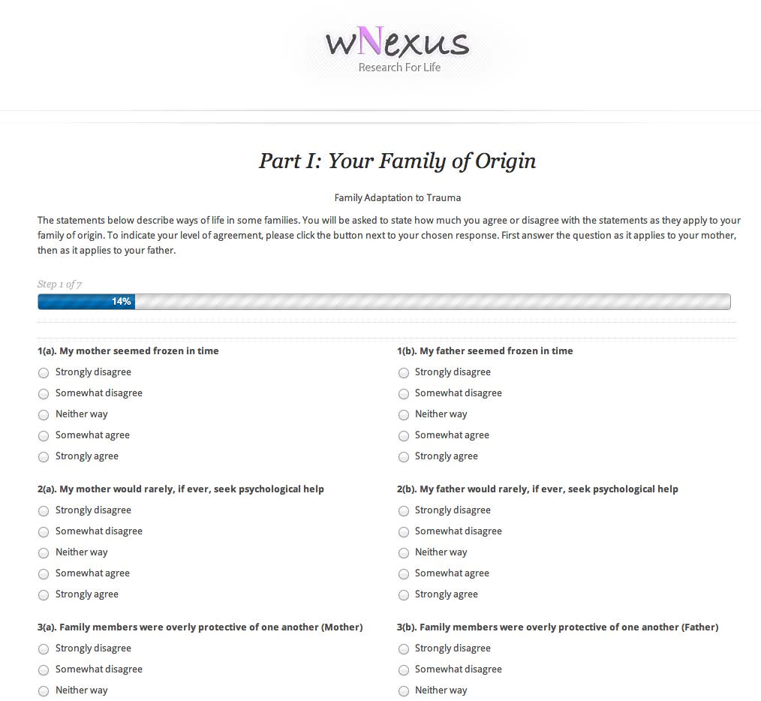

The column to the left of the items shows the scale to which the item belongs: V for Victim, N for Numb, F for Fighter. Parent scales are scored as the mean of component items, giving each scale a potential range of 1-5. A few items on the list of questions are marked REVERSED. Before computing scale scores, these items should be recoded (1=5, 2=4, 3=3, 4=2, 5=1).

Reparative Adaptational Impacts (Offspring Measures, Part II)

Part II has 36 self-descriptive statements answered on a 5-point Likert scale (strongly disagree = 1, disagree = 2, neither way = 3, agree = 4, strongly agree = 5). The instructions read,

The statements below describe you and your way of life. You will be asked to state how much you agree or disagree with the statements as they apply to you.

The order of the questions has been randomized. The screenshot below illustrates the layout we used in the original web survey.

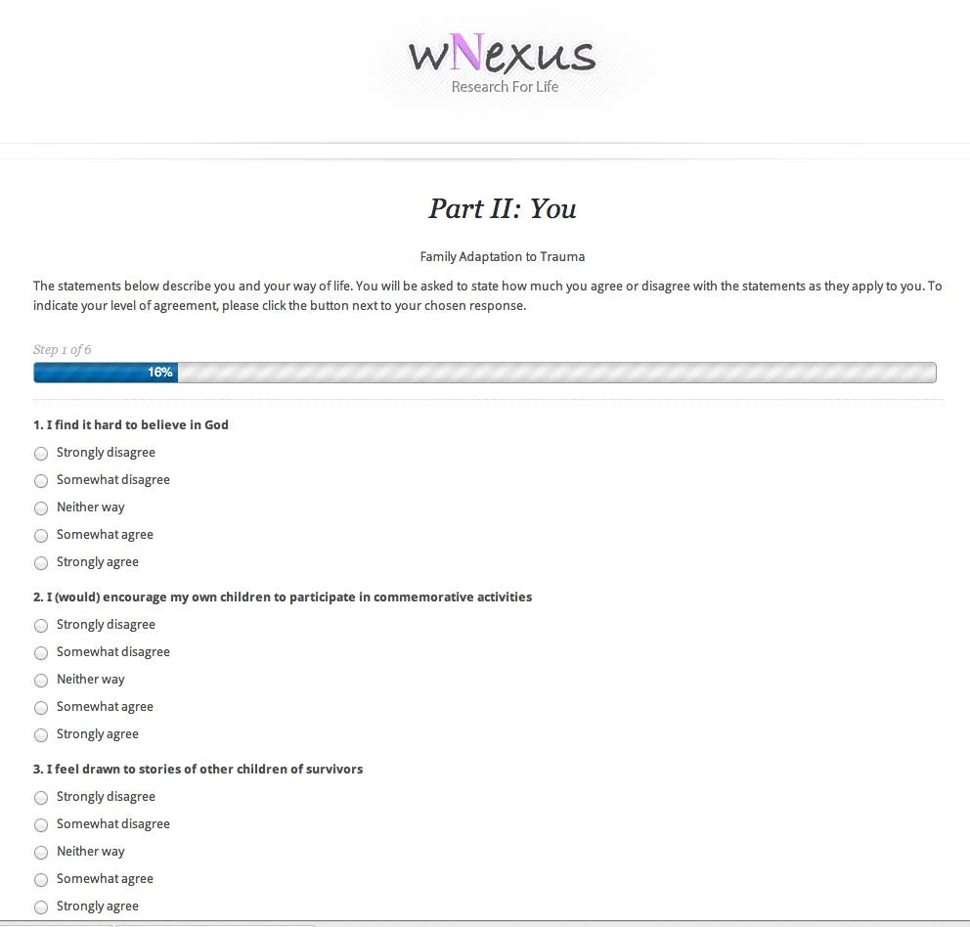

The scale is scored as the mean of component items, giving it a potential range of 1-5. A few items on the list of questions are marked REVERSED. Before computing scale scores, these items should be recoded (1=5, 2=4, 3=3, 4=2, 5=1).
Family History and Context (Four-Generation Sociodemographic Description, Part III)

Part III of the survey consists of a series of questions organized into sections. We strongly recommend placing the first section, Preliminary questions/participant status, before Part I, but keeping the remaining sections beginning with Family size, composition, survivorship and loss after Part II.

The instructions read,

The following questions are about your family’s history, characteristics, and circumstances. Please answer all questions to the best of your ability.

We do not recommend randomizing the order of Part III items but rather following the sequence shown.

These items are scored individually rather than as a scale.

List of Publications

More information about the inventory’s development and use can be found in the following publications.

Danieli, Y., Norris, F., Lindert, J., Paisner, V., Engdahl, B., & Richter, J. (2015). The Danieli Inventory of Multigenerational Legacies of Trauma, Part I: Family adaptational styles. Journal of Psychiatric Research, 68, 167-175.

Danieli, Y., Norris, F., Lindert, J., Paisner, V., Kronenberg, S., Engdahl, B., & Richter, J. (2015). The Danieli Inventory of Multigenerational Legacies of Trauma, Part II: Reparative Adaptational Impacts. American Journal of Orthopsychiatry, 85(3), 229-237.

Danieli, Y. Norris, F. & Engdahl, B. (2016).Multigenerational legacies of trauma: Data-based integrative modeling of the what and how of transmission. American Journal of Orthopsychiatry, 86(6), 639-651.

Danieli, Y., & Norris, F. (2016). A Multidimensional exploration of the effects of identity ruptures in Israeli and North American Holocaust survivors: Clinical, policy, and programmatic Implications. Kavod: Journal of Caring for Holocaust Survivors, 6(1). http://kavod.claimscon.org/2016/01/1400/#respond

Danieli, Y, Norris, F., & Engdahl, B. (2017). A question of who, not if: Psychological disorders in children of Holocaust survivors. Psychological Trauma: Theory, Research, Practice, and Policy, 9 (S1), 98-106.

SHORT FORMS
Parents’ Posttrauma Adaptational Styles (PTAS) SHORT FORM (SF)

All items are answered on a 5-point Likert scale: strongly disagree = 1, disagree = 2, neither way = 3, agree = 4, strongly agree = 5.

The PTAS Victim Style Scale SF has 20 items, asked separately for mothers and fathers (total = 40 items). It omits Items 7, 10, 17, 19, 24, 28, 30, 41, 48, and 55 from the randomized list.

SF item # | randomized item # | PTAS Victim Style Scale
Vsf1 | 1 | Privacy was not allowed (mother/father)
Vsf2 | 4 | The Holocaust/genocide/war ª was always present in the house (mother/father)
Vsf3 | 11 | Compared to other mother/fathers, my mother/father seemed older than she/he actually was
Vsf4 | 14 | My mother/father often screamed in order to feel heard
Vsf5 | 15 | My mother/father used shame to control my behavior
Vsf6 | 18 | My parents often seemed disappointed in each other (mother/father)
Vsf7 | 20 | My mother/father always ate very quickly as though the food would disappear
Vsf8 | 22 | My mother/father seemed frozen in time
Vsf9 | 25 | My mother/father might erupt in violent outbursts, then weep with regret
Vsf10 | 33 | My mother/father's behavior sometimes terrified me
Vsf11 | 35 | At times, my mother/father would suddenly look as if she/he were far away
Vsf12 | 36 | My mother/father reacted in a catastrophic way to even minor changes
Vsf13 | 39 | My mother/father seemed strange when compared to other mother/fathers
Vsf14 | 42 | My mother/father worried about everything
Vsf15 | 44 | Our home was full of sadness (mother/father)
Vsf16 | 45 | In our home, even the smallest decision had to be carefully considered (mother/father)
Vsf17 | 51 | It was very difficult for my mother/father to provide reasonable limits
Vsf18 | 54 | Family members were overly involved in each other’s lives (mother/father)
Vsf19 | 58 | My mother/father felt down on ethnic/religious ª holidays
Vsf20 | 60 | My mother/father used guilt to control my behavior

The PTAS Numb Style Scale SF has 15 items, asked separately for mothers and fathers (total = 30 items). It omits Items 12, 37, and 47 from the randomized list.

SF item # | randomized item # | PTAS Numb Style Scale
Nsf1 | 2 | Weakness was not tolerated in our home (mother/father)
Nsf2 | 5 | Affection and open expression of love were rare in our home (mother/father)
Nsf3 | 8 | Closeness was rare (mother/father)
Nsf4 | 13 | In our family, feelings of distress were not to be admitted (mother/father)
Nsf5 | 16 | My mother/father often told me how important I was to her/him/them REVERSED
Nsf6 | 23 | In our family, the Holocaust/genocide/war ª was never mentioned (mother/father)
Nsf7 | 26 | My mother/father never discussed her/his Holocaust/genocide/war ª experiences
Nsf8 | 27 | Open communication seemed not to exist in our home (mother/father)
Nsf9 | 29 | My mother/father often told me she/he loved me REVERSED
Nsf10 | 32 | Our home was devoid of emotions (mother/father)
Nsf11 | 34 | It felt dangerous to express emotions at home (mother/father)
Nsf12 | 43 | I never knew which of my questions/comments would upset my mother/father so I chose to not speak my mind
Nsf13 | 50 | My mother/father did not give me any guidance
Nsf14 | 52 | Humor was present even when things were difficult (mother/father) REVERSED
Nsf15 | 59 | While we were praised for achievements, there was little sense of intimacy in the family (mother/father)

The PTAS Fighter Style Scale SF has 10 items, asked separately for mothers and fathers (total = 20 items). It omits Items 21 and 31 from the randomized list.

SF item # | randomized item # | PTAS Fighter Style Scale
Fsf1 | 3 | Other than with family members, we socialized almost entirely with other survivors from my parent's original community (mother/father)
Fsf2 | 6 | My parents' house was always stocked with food (mother/father)
Fsf3 | 9 | I was taught to honor and remember the history of my/our people (mother/father)
Fsf4 | 38 | I was taught to fight against injustice (mother/father)
Fsf5 | 40 | The continued safety of Israel/Ireland/Armenia ª is a major concern in our family (mother/father)
Fsf6 | 46 | My mother/father taught me to be ready for anything that might happen in life
Fsf7 | 49 | I was taught to stand up to authority (mother/father)
Fsf8 | 53 | My mother/father viewed marrying outside the faith/group/race/ethnic/social group ª as a betrayal
Fsf9 | 56 | My mother/father wouldn’t buy German/British/Turkish ª goods REVERSED
Fsf10 | 57 | I was taught that people should never forget crimes committed against humanity (mother/father)

Reparative Adaptational Impacts (RAI) SHORT FORM

The RAI SF has 30 items. Omitted are Items 5, 10, 15, 16, 27, and 28. All items are answered on a 5-point Likert scale: strongly disagree = 1, disagree = 2, neither way = 3, agree = 4, strongly agree = 5.

randomized item # | Item
1 | Sometimes I felt I had to fill in for murdered family members
2 | I find it uncomfortable to be in a position of authority
3 | Most days I wake up looking forward to life REVERSED
4 | It is very hard for me to just relax
6 | I find it difficult to say goodbye
7 | I feel responsible for my parent's/s' happiness
8 | I find it difficult to delegate responsibility to others
9 | Even when successful, I feel forlorn
11 | I think of my parents as vulnerable
12 | I worry that others will look down on me
13 | My peers’ concerns often seemed frivolous to me
14 | I am afraid to imagine what led to my parent's/s' numbness
17 | I had to seek guidance outside the family about how to live my life
18 | I have often resorted to alcohol, substance abuse, sex or food to soothe myself
19 | I am very sensitive to being labeled
20 | I fear(ed) bringing children into a world
21 | Contentment is a foreign concept to me
22 | Sometimes I felt overwhelming despair when I didn't live up to my parent's/s' expectations
23 | My first reaction to a new task is, “I can’t…”
24 | I test my ability to survive by continuously taking risks
25 | The culture of the society we live in does not encourage expression of emotions
26 | I have sometimes felt a need to make up for my family's losses
29 | When there is illness in the house, I feel it is my responsibility to make sure that every detail is taken care of
30 | It is important for me to feel powerful
31 | I am very sensitive to being criticized
32 | It is important to me to be in total control
33 | I often experience physical pain (headache, backache, etc.) when I feel difficult, stressful emotions
34 | I expect people to take advantage of me
35 | I am obsessed with watching and reading everything about my parent's/s' experiences
36 | I would feel I had betrayed my family and myself if didn't respond to any negative remark about my faith/group/race/ethnic/social group

