Endowed by Slavery

[Andrew Delbanco](https://www.nybooks.com/contributors/andrew-delbanco/)

The history of university coffers suggests a centuries-long conversion of blood money into benefactions.

[June 23, 2022 issue](https://www.nybooks.com/issues/2022/06/23/)

Reviewed:

[**Ebony and Ivy: Race, Slavery, and the Troubled History of America’s Universities**](https://www.bookshop.org/a/312/9781608194025)

by Craig Steven Wilder

Bloomsbury, 423 pp. (2013)

[**Slavery and the University: Histories and Legacies**](https://www.bookshop.org/a/312/9780820354422)

edited by Leslie M. Harris, James T. Campbell, and Alfred L. Brophy

University of Georgia Press, 354 pp., $99.95; $34.95 (paper)

[**The Princeton Fugitive Slave: The Trials of James Collins Johnson**](https://www.bookshop.org/a/312/9780823294077)

by Lolita Buckner Inniss

Fordham University Press, 238 pp., $70.00; $19.95 (paper)

 See All

[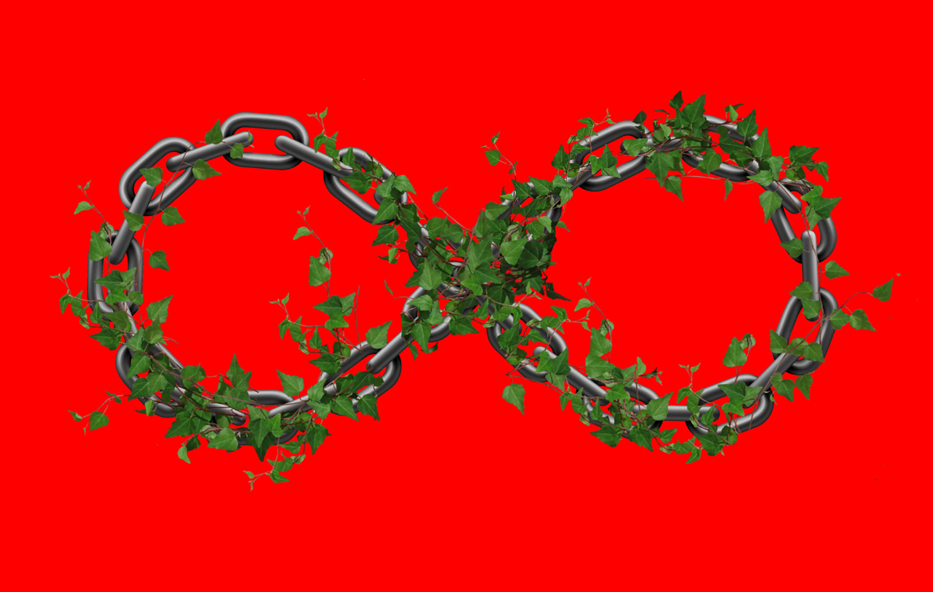](https://www.nybooks.com/wp-content/uploads/2022/05/delbanco_1-062322.jpg)

Illustration by Office of Paul Sahre

1.

At the end of April, with the release of its “Report of the Presidential Committee on Harvard and the Legacy of Slavery,” Harvard made headlines by announcing that it would devote $100 million to remedying “the harms of the university’s ties to slavery.” It was the latest effort by a venerable university with demonstrable connections to slavery to answer the question of what it owes to Black Americans.

Until recently, this question yielded no answers because no one asked it. If you consult the standard histories, you won’t find it. Samuel Eliot Morison’s *Three Centuries of Harvard*, published in 1936 to mark the tricentennial of our oldest university, counts Isaac Royall among “a number of unusually intelligent and cultivated gentlemen” who served on its Board of Overseers in the eighteenth century. But Morison doesn’t mention that Royall profited from the labor of slaves, including, for fifty years, an African-born woman named Belinda Sutton, who in 1783 successfully petitioned the Massachusetts General Court for an old-age stipend to be drawn from his estate.

As for the oldest college in the South, a commemorative volume about the College of William and Mary published soon after the Civil War reports that “the foundation of the president’s house was laid on the 31st of July, 1732,” at a ceremony where five dignitaries—listed by name, starting with President James Blair—took turns “laying the first five bricks in order one after another.” But we learn nothing about the workers who laid the rest of the bricks so that Blair and his family could move in.

None of this—neither the facts nor the exclusion of the facts—should be surprising. For a very long time, not only historians of higher education, but most historians of just about everything else, failed to acknowledge the malignant infiltration of slavery into every corner of American life.

 With significant exceptions—notably the distinguished Black historians Lorenzo Greene and Benjamin Quarles, who built on the foundational work of W.E.B. Du Bois—it was not until after World War II that scholars began to come to terms with the manifold horrors of slavery.

Well into the twentieth century the view persisted that it had been a natural, if lamentable, form of human relations. The major work on the subject, published in 1918, was Ulrich B. Phillips’s *American Negro Slavery: A Survey of the Supply, Employment and Control of Negro Labor as Determined by the Plantation Regime.*Phillips was born in Georgia in 1877, the year Reconstruction effectively came to an end and federal troops withdrew from the South. In his telling, before the trauma of a disastrous war and the insult of occupation, southern life had been something close to a biracial utopia. Black children, hand in hand with their white playmates,

were regaled with folklore in the quarters, with Bible and fairy stories in the “big house,” with pastry in the kitchen, with grapes at the scuppernong arbor, with melons at the spring house and with peaches in the orchard.

He conceded that the parents of these children were forced, under the scorching sun, to submit to a “system [that] gave some stimulus to speed of work, at least from time to time,” but he didn’t say whether the “stimulus” was applied by words or by whips. Either way, it was made bearable by the “promise of afternoon leisure in reward.”

This benign and even communitarian version of slave culture was by no means confined to historians born and bred in the South. Phillips took his Ph.D. in 1902 at Columbia under William Dunning, the leading scholar of Reconstruction at the time, who had grown up in New Jersey and focused on the sufferings of “afflicted white people” in the former slave states. Through the work of these and other prominent scholars, the image of Black people as childish, primitive, and unfit for self-rule migrated into popular culture, where it found expression in such movies as *Birth of a Nation* (1915), *Gone with the Wind* (1939), and their many imitations. In 1929 Columbia affirmed its pride in Phillips by awarding him an honorary degree.

In the late 1940s and early 1950s a new generation of historians—including John Hope Franklin, Frank Tannenbaum, Stanley Elkins, and Kenneth Stampp—began to document the psychological mutilations inflicted by what Ta-Nehisi Coates has more recently called “the for-profit destruction of the most important asset available to any people, the family.” In the 1960s two younger scholars, Winthrop Jordan and David Brion Davis, opened a new avenue of study by treating racism and slavery as problems in intellectual history. But even they paid almost no attention to the ways colleges developed and transmitted ideas about the natural necessity of racial subjugation.

One reason, perhaps, that academic institutions were spared from scrutiny was that they seemed, by design, to be physically removed from the vulgar transactions of commercial life. The trading houses where merchants contracted for consignments of cotton, rum, molasses, and human chattel; the insurance firms that indemnified slave owners for loss of human property; the clothiers that manufactured coarse smocks for enslaved field hands—all these were likely to be found among shops and markets, close to the banks from which they obtained credit and the wharves where human goods were loaded or unloaded for sale.

Think, on the other hand, of our early colleges: Harvard on its bluff above the Charles River, or Yale looking across New Haven Green toward the Long Island Sound, or Brown atop the heights of Providence. Their architecture (ecclesiastical) and setting (pastoral) seemed to say, “We stand above the fray, removed from the workaday world, in a high-minded sphere of our own.” For people like me whose shelves are filled with books about these colleges, it’s not a bad idea to paste a note every foot or so along the edge of the shelf bearing this reminder from the novelist James McBride: “The web of slavery is sticky business. And at the end of the day, ain’t nobody clear of it.”

2.

The moment when the fairy tale about pure and cloistered colleges began to fall apart can be dated with some precision. It happened in 2001, when Brown appointed as its president Ruth Simmons, the first African American to lead an Ivy League institution. Simmons, whose great-grandparents were enslaved and whose father was a sharecropper in Texas, holds a Harvard Ph.D. in French literature and led Brown for over a decade before taking up the presidency of Texas Prairie View A&M, an institution founded in the era of segregation to serve Black students. Simmons may have brought to Brown a clearer view of the American past than had any previous president of a historically white college. Soon after taking office, she charged a faculty committee with investigating the university’s connections to slavery.

The trail of evidence led straight back to its founding benefactors, the Brown brothers, who were among Rhode Island’s leading merchants in the eighteenth century. One of their business ventures was a joint investment in a slave ship, the *Sally*, that sailed in the summer of 1764 from Providence to West Africa, laden with barrels of rum. In response to President Simmons’s mandate, a group of Brown University historians chronicled the voyage. All along the Guinea coast, the *Sally* cruised from harbor to harbor, providing rum to passing ships in exchange for cloth, guns, and other goods that could be traded for slaves: “Slaves trickled in one or two at a time, acquired from other slave ship captains, from British and Afro-Portuguese traders operating in the area, and from the local African king.” Now and then the ship dispatched a boat upriver, where more slaves could be acquired at inland markets.

Just under two hundred enslaved men, women, and children were eventually taken aboard. Once the captain felt he had obtained enough, he set sail west to the Caribbean on the second leg of the so-called triangle trade, with the intent of exchanging the slaves for sugar and molasses, to be brought back to Rhode Island for distillation into rum so that the vicious cycle could begin again. During the voyage more than half of these human beings died, from suicide, malnutrition, disease, or in a shipboard insurrection put down by gunfire.

Back in Providence, three of the four Brown brothers, having lost much of their investment, refrained from further involvement in the slave trade. The youngest, Moses Brown, felt that the whole enterprise had been a moral as well as a financial disaster—so much so that when his wife died, he believed her death was God’s judgment against him. His brother John, however, felt no such compunction, and, hoping for better luck next time, he invested in more slave-trading voyages.

Brown University led the way toward a more general reckoning with the academic past. The next two decades brought a cascade of research projects, conferences, and official apologies from universities with historical ties to slavery, including the University of Alabama (2004), William and Mary (2009), Emory (2011), Georgetown (2017), and the University of North Carolina (2018), among many others. A website maintained by the University of Virginia provides links to such projects not only in the United States but around the world. The last time I checked, it listed ninety-five institutions that have formed research initiatives to uncover the sordid aspects of their past. With the rise of the Black Lives Matter movement, and the string of horrors from the killing of Trayvon Martin in 2012 to the mass shooting at Charleston’s Mother Emanuel Church in 2015 and the murder of George Floyd in 2020, these efforts grew. The latest rampage by a murderous racist, in Buffalo, New York, will and should accelerate them further.

A milestone was reached in 2011, when a group of scholars, led by the Emory historian Leslie M. Harris (now at Northwestern), gathered at Emory to share their research. Two years later, one of the participants, Craig Steven Wilder, a professor of history at MIT, published a breakthrough book that had long been in gestation, *Ebony and Ivy: Race, Slavery, and the Troubled History of America’s Universities*. Wilder’s argument was blunt and stark: “The academy never stood apart from American slavery—in fact, it stood beside church and state as the third pillar of a civilization built on bondage.”

For Wilder, “the American campus stood as a silent monument to slavery.” His book changed the experience of visiting any American college established before the Civil War, except for the few, such as Berea and Oberlin, that had been founded by abolitionists. Amid the quiet quads and lawns, disembodied voices now whisper “shame.” The eye is drawn to names chiseled in the stone of campus buildings—names of patrons who in some cases profited from the labor or service of enslaved people. Wilder identified innumerable slaveowners, traders, ideological allies, and fellow travelers who provided the rationale, as well as financiers who provided the capital, for a commerce that treated human beings as if they were no different from livestock or grain. He turned the honor roll of Alma Mater into a bill of indictments.

The two campuses I know best—Harvard, where I was a student and briefly a teacher, and Columbia, where Wilder took his Ph.D. and where I have taught for more than thirty-five years—are cases in point. At Harvard, a stately frame building called Wadsworth House was constructed in 1726 on what is now the southern edge of Harvard Yard. For years I walked past it, knowing it contained the office of the university marshal—the official who led the commencement procession and organized the pomp and ritual for honorary degree recipients. I knew, too, that it was once the residence of Harvard’s first professor of medieval history, Henry Adams. But now I know that it is named for Harvard president Benjamin Wadsworth, who kept slaves in the house, and that Adams’s grandfather Peter Chardon Brooks made his fortune in part by insuring vessels engaged in the slave trade.

When I arrived at Columbia in 1985, the undergraduate division of the main library was named for the political-science professor John W. Burgess, who had gone off as a young man to Cumberland University in Lebanon, Tennessee, accompanied, as Du Bois put it, by “a box of books, a box of tallow candles and a Negro boy,” and whose “attitude toward the Negro race in after years was subtly colored by this early conception of Negroes as essentially property like books and candles.” Other names attached to Columbia are all over Wilder’s book or in research projects he inspired: McVickar, Livingston, Bard, and Havemeyer, among others.

The Havemeyer family, whose name adorns the building that houses Columbia’s chemistry department, made its fortune refining slave-grown sugar imported largely from Cuba and Louisiana. The building where I teach is named for Alexander Hamilton, who, thanks to Lin-Manuel Miranda, enjoys a reputation today as a proto-abolitionist and prophet of multiracial America. But Wilder points out that in Hamilton’s student days at King’s College (Columbia’s prerevolutionary name), his fees were paid by a merchant to whom he had been apprenticed on the island of Saint Croix and who got rich by supplying Caribbean plantations with mules, flour, and slaves.

Among Wilder’s subjects is one with which anyone in the academic world is well acquainted: the perpetual chase after money. In the case of Princeton (which, in proportion to its number of students, has chased down more money than anyone else), its eighteenth-century president John Witherspoon carried the collection plate to the West Indies. So many men of “opulence” (Witherspoon’s word) were to be found there that all the way from Nassau Hall he imagined hearing their gold clinking into the college coffers.

Then as now, college presidents proceeded on what might be called the Willie Sutton principle: they went where the money was. So much of it was with slave owners or other beneficiaries of the slave system that Wilder’s book might seem to be about the conversion of blood money into benefactions through a centuries-long money-laundering scheme intended to rehabilitate the reputations of the donors. (That’s my characterization, not his.) But in fact, almost no one at the time felt there was anything illicit about the way the money was made.

Colleges were part and parcel of the public financial system, which was closely integrated with the slave economy. From State Street in Boston to Wall Street in New York and Broad Street in Philadelphia, northern banks made loans to southern growers of cotton, tobacco, indigo, hemp, and other crops for export or domestic consumption. By the second decade of the nineteenth century, the largest manufacturer weaving slave-grown cotton into cloth durable enough to withstand heat and sweat was located not in Baltimore or Richmond but along the Hudson River, in Dutchess County, New York. By the mid-nineteenth century, nearly half of the forty textile manufacturers in Rhode Island were supplying slaveowners with what was known as “Negro cloth.” Throughout the North, not only crude clothes for field hands but luxury items for the expanding middle class—from pipe tobacco to sweet desserts—were the product of slave labor in the South. In 1844 Ralph Waldo Emerson remarked that when his fellow New Englanders spooned sugar into their tea or savored their cake, “no one tasted blood” in the treats. Harvard, from which Emerson had graduated two decades earlier, functioned in its own right as a bank by making interest-bearing loans to merchants who used the borrowed capital to finance their slave-trading business.

Financial entanglement was only one aspect of slavery’s tentacular reach. America’s colleges—especially but not exclusively in the South—were also sites for training young men in the habits of mastership. As Craig Hollander and Martha Sandweiss note in the essay collection *Slavery and the University*,Princeton was long a favorite northern college for sons of planters: more than 60 percent of the class of 1851 came from slave states. In 1843 a fugitive from Maryland named James Johnson, who did odd jobs for students, was threatened with rendition back to the owner from whom he had fled. He was saved when a local woman intervened and bought his freedom. According to the historian Lolita Buckner Inniss, who tells Johnson’s story in *The Princeton Fugitive Slave*, this woman may not have put up the money herself but agreed to be the conduit for funds raised from associates of the college who didn’t want southern supporters to know that they had conspired with a fugitive deemed guilty of having stolen himself.

Although Johnson was legally emancipated, it would be a stretch to call him free. A few years after his liberty was purchased, he was pictured in a Princeton student magazine cartoon dripping with excrement after diving into a latrine to retrieve some bit of property—a silk handkerchief, perhaps, or a gold pocket watch—that a college kid had dropped in the slime and wanted back without having to soil himself. This kind of thing was not unusual. As Wilder puts it, “college boys felt particularly entitled to terrorize slaves and servants.” It was fun.

Thomas Jefferson, whose attitude toward slavery was somewhere between inconsistency and hypocrisy, was a graduate of William and Mary, which owned a tobacco farm worked by thirty slaves that generated revenue to support white scholarship students. His qualms about slavery were largely about its effects on white people, as when he described

the unhappy influence on the manners of our people produced by the existence of slavery among us. The whole commerce between master and slave is a perpetual exercise of the most boisterous passions, the most unremitting despotism on the one part, and degrading submissions on the other. Our children see this, and learn to imitate it; for man is an imitative animal.

As the historian Alan Taylor suggests in *Thomas Jefferson’s Education*, Jefferson hoped these tendencies could be tempered by a new university that would produce future fathers who would set better examples for their sons. To this end, the Board of Visitors (which included James Madison) of the University of Virginia, founded by Jefferson in 1819, resolved, along with prohibitions against alcohol, dueling, and “games of chance,” that no student shall “keep a servant, horse or dog.” Despite the founders’ wish, students continued to depend on slaves for blackening their shoes, supplying fresh water, and who knows what else.

But academia’s biggest gift to the slaveholders was the constellation of ideas that today is called white supremacy. Especially but not exclusively in the South, professors promoted what the historian Patrick Jamieson, writing about the antebellum curriculum at Emory, calls “the essential rectitude” of slavery. Scientists contributed the theory of “polygenesis,” according to which different races were less like siblings and more like separate species descended from multiple ancestors. Theologians who remained devoted to the biblical doctrine that all humanity descends from one common pair of parents got around that obstacle by tracing the genealogy of Black people back to Noah’s wayward son, Ham, whose posterity was cursed to bear the ignominy of dark skin. Such ideas were disseminated through authoritative books and lectures.

All these arguments amounted to the claim that Black people were alien and inferior. Better to deport than support them. This was the premise on which, in 1816, the American Colonization Society was founded for the purpose of sending back to Africa a people who, in Wilder’s paraphrase of one antebellum Harvard president, were “misplaced Africans.” Any effort to educate them for full participation in American society was thought to be misguided. When in 1830 an effort arose to open a “Negro College” in New Haven, Yale put a quick end to it. A few years later, when the abolitionist Prudence Crandall established an academy for Black women forty miles away in Canterbury, Connecticut, she met the same opposition, rooted in the view that Blacks could never be assimilated no matter how much they were schooled.

It should be said that antebellum colleges did not march in lockstep on all these matters. Curricula reflected regional differences, even down to the choice of textbooks. Most college students were required to take what we would call a “capstone” course in moral philosophy, typically taught by the college president. Then as now, publishers competed to provide the textbook. First published in 1835, *The Elements of Moral Science* by Francis Wayland—an early president of Brown—was the perennial best seller. But because Wayland believed that “the moral precepts of the Bible are diametrically opposed to slavery,” southern colleges—hoping to prevent subversive ideas from infecting the minds of the sons of planters—replaced his text with others that judged the peculiar institution to be perfectly consistent with Christian ethics.

While the issue of slavery divided northern from southern colleges, it also opened internal rifts within colleges. In 1835 Harvard expelled its first professor of German, Charles Follen, for his outspoken antislavery views. Three years later, with abolitionists roaring all over New England, the Harvard Corporation decreed that no one unaffiliated with Harvard would be allowed to speak on campus without preapproval by faculty vote. Yet the same college that banned abolitionists produced graduates who participated in the struggle against slavery—including Emerson, class of 1821, and Henry David Thoreau, class of 1837, who brought intellectual prestige to the antislavery cause; Thomas Wentworth Higginson, class of 1841, who aided John Brown and commanded a regiment of Black volunteers in the Civil War; and Robert Gould Shaw, class of 1860, who withdrew from college to fight in the war and died beside hundreds of his Black comrades in the failed assault on Fort Wagner in South Carolina.

Columbia, which in those years served the sons of Confederate-sympathizing New York City merchants, nevertheless became a refuge for intellectuals disaffected by what they had seen of slave culture in the South—men such as Frederick Barnard and Francis Lieber, both of whom had lived and worked in the South (Barnard in Mississippi, Lieber in South Carolina) and had even owned slaves, but who became antislavery Unionists.

3.

Wilder’s *Ebony and Ivy* and the many subsequent articles, reports, and monographs that took up his theme are essential reading for anyone concerned with the question of what higher education owes to Black Americans. But the keyword in that question, “owe,” has two meanings that ought to be distinguished. The first is retrospective, as in “I owe my career to my teachers” or “I owe my life to my doctor.” Using the word in this sense, we mean that without *x* there would be no *y*; but there is no claim that *y* should give anything to *x* beyond acknowledgment or thanks.

It has become routine to acknowledge the debt universities owe to Black Americans in this retrospective sense. In 2016 Harvard president and Civil War historian Drew Gilpin Faust was joined by Congressman John Lewis in dedicating a plaque, now affixed to Wadsworth House, honoring four enslaved persons who had once lived there. In 2017 Yale’s authorities belatedly recognized that asking Black students to live in a residence hall named for the chief ideologue of slavery, John C. Calhoun, where a stained-glass window depicted him lording it over a shackled slave,

 was not very different from, say, asking Jewish students to live in a building named for Joseph Goebbels. Calhoun College has since been renamed in honor of a distinguished alumna, the computer scientist Grace Murray Hopper.

But there is a second meaning of the word “owe” that makes one wonder whether such actions, welcome as they are, amount to more than self-soothing gestures. This is the prospective meaning that points to an unmet obligation, as in “I owe you a favor.” It looks to a time when the speaker intends to reciprocate some gift or service received in the past. How and to whom the debt should be paid for the uncompensated labor of generations of Black people is a difficult question—but surely more is required than taking down old names and putting up new ones.

Among the speakers at a recent Harvard conference following the announcement of its reparations fund was Ruth Simmons. She pointed out that

reaching back in history to judge how historical figures acted and judging them in the context of more evolved and enlightened laws and human rights protection can be a treacherous undertaking. It can also consign us to an endless succession of accusations and revisions that detract from the urgency of current behaviors and problems.

The impulse to chastise people in the past can be a distraction not only for Harvard but for any wealthy institution that would move beyond memorialization to ask what, exactly, its future responsibilities within and beyond its own campus are.

The “Report of the Presidential Committee on Harvard and the Legacy of Slavery” is thin on answers. It speaks of establishing partnerships with historically Black colleges and universities that would foster faculty and student exchanges as well as sabbatical research leaves for HBCU professors. Following Brown, which in 2007 established an endowed fund of $10 million to support public schools in Providence, Harvard aims, more grandly but rather vaguely, to “leverage its scholarly excellence and expertise in education” through an array of institutions including “schools, community colleges, tribal colleges, universities, and nonprofit organizations” that serve “descendant communities”—a euphemism for people whose ancestors were enslaved or who otherwise suffered from the stigma of being Black or brown in white America.

 After the report was released, one faculty member suggested that Harvard should increase its efforts to provide education for incarcerated persons, who are disproportionately people of color, and curtail its investments in businesses that profit from their labor. Martha Minow, the respected former dean of Harvard Law School, will lead a committee to develop more concrete proposals.

Not surprisingly, complaints are already afoot that Harvard isn’t doing enough. Speaking on Fox News, of all places, Nikole Hannah-Jones, the founder of the 1619 Project, described the dollar amount as “way too low.” At the recent Harvard conference, Densil Williams, a vice-chancellor of the University of the West Indies, called for an initial investment closer to $200 million, which he estimates is less than two months’ interest on Harvard’s $50 billion endowment, “to fund scholarships for the next thirteen years for three hundred persons across the African and Caribbean Pacific region” in “robotics, artificial intelligence, big data, the internet and all those things that matter for the new economy.”

While the report celebrates Harvard’s role in championing “race-conscious admissions policies in our courts of law,” it does not mention the possibility that the US Supreme Court may soon prohibit consideration of race in evaluating candidates for college admission. With that decision looming, one hopes (however the Court ultimately rules) that selective colleges such as Harvard are working to develop specific strategies—for example, “bridge” programs to prepare students for college, and counseling students in large urban high schools, where the ratio of students to counselors can be many hundreds to one—if they are to avoid what happened at flagship public universities, such as the University of Michigan or UC Berkeley, in states where bans on affirmative action produced a drastic decline in the percentage of Black students.

Whatever happens to the admissions process at selective colleges, the overwhelming majority of Black students attend four-year public institutions or two-year community colleges, which face chronic shortfalls in tuition revenue and state subsidies, and which struggle to provide support, especially for low-income and minority students. These students won’t be hurt or helped by changes in Ivy League demographics.

As for what universities can do beyond ensuring the presence of Black students, they have three basic functions: to conduct research, to teach, and to serve the communities in which they exist. This third responsibility is the least defined and has not been taken seriously enough by wealthy private institutions, which enjoy exemption from taxation on their real estate holdings and returns from their endowments, and whose donors take tax deductions for their gifts—all of which represents revenue withheld from the public treasury.

The first two functions—research and teaching—have contributed a great deal in recent years to improving public understanding of racial inequities in America and their relation to the crime of slavery. For those who argue, with Senator Mitch McConnell, that “reparations for something that happened 150 years ago” is not a good idea, there is a growing body of scholarly work that illuminates the insidious strategies by which, long after slavery, Black Americans continued to be treated as subcitizens: the sharecropping system that locked agricultural workers into inescapable cycles of debt; the exploitation of convict labor whereby Black men were snatched off the streets for such crimes as “vagrancy” and put to work in factories or mines; the fact that while the United States was building the semblance of a welfare state in the mid-twentieth century, millions of Black Americans were excluded either de jure or de facto—not to mention the everyday degradations of Jim Crow.

 Whatever their sources in the past, terrible disparities remain between Black and white Americans in family assets, child poverty, infant mortality, maternal deaths in childbirth, and educational attainment, to name just a few.

The responsibility of universities to serve communities—and not just Black communities—beset by these and many other social pathologies is far beyond the capacity of any one institution to discharge with large effect. But by working together they could make some positive difference toward improving public health, precollege education, and the supply of affordable housing. Unfortunately, universities—especially prestigious ones—typically prefer competition to collaboration, and they seem now to be trying to outdo each other in what has been called, somewhat acidly, “contrition chic.” In this contest it is sometimes hard to distinguish self-abasement from self-congratulation.

The burgeoning discussion of what universities can and should do on behalf of racial justice is part of a larger debate over reparations. One leading figure in that debate, the Duke University public policy professor William Darity, has suggested that universities should “pursue having a national program of reparations, and…use their clout and influence to make that happen.” The moral, logistical, and political barriers to such a program seem impossibly high: how to distribute liability for crimes of the past among present-day citizens; how to identify qualified recipients of compensatory payments; and most daunting of all, how to overcome the fact, as Dalton Conley writes in his contribution to *Politics and the Past*, that “reparations combine two policies that have been wildly unpopular in American political culture: taxes and group preferences.” The reparations debate is nonetheless imperative for building public recognition of the devastating historical experience of Black Americans during the era of slavery and long after.

The social theorist John Torpey, who writes with uncommon nuance about the theory and practice of reparations, has expressed doubt that today’s “swelling attention to the iniquitous past” will do much to secure a better future. It’s a fair warning. Still, in the narrower setting of colleges and universities, it is encouraging that the veil has been lifted from a scandal long hidden or shrugged off.

*This essay was delivered, in slightly different form, at Mercer University on March 24, 2022, as the first of three Malcolm Lester Phi Beta Kappa Lectures.*

This Issue

June 23, 2022

[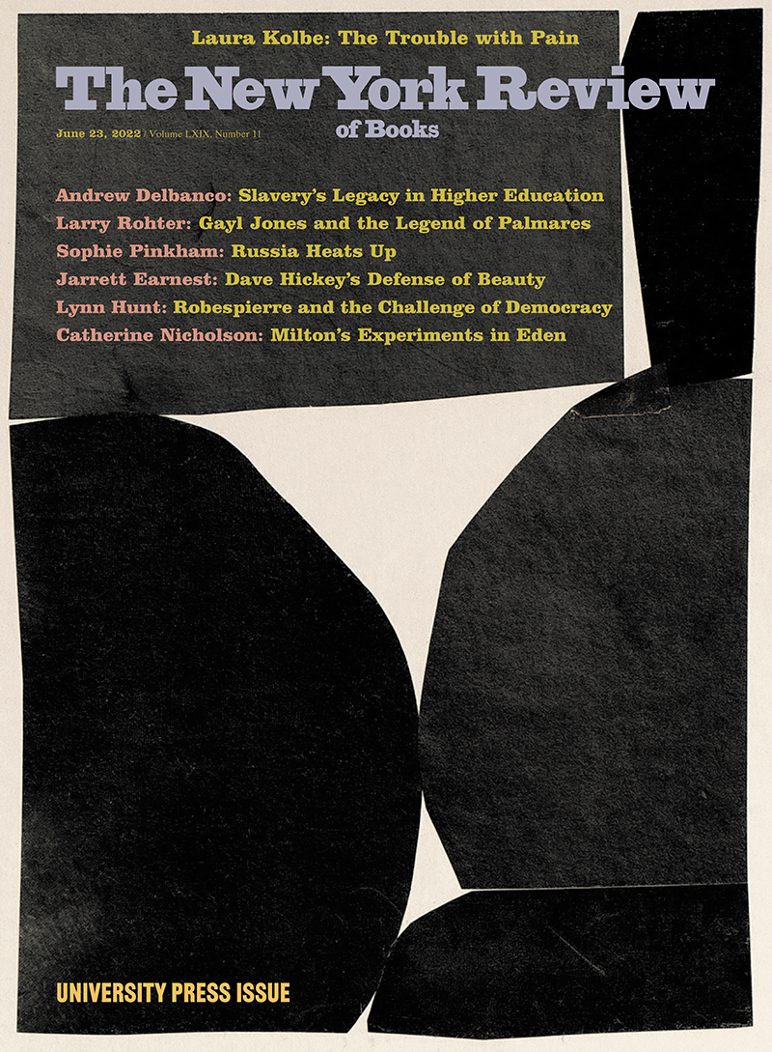](https://www.nybooks.com/issues/2022/06/23/)

[Andrew Delbanco](https://www.nybooks.com/contributors/andrew-delbanco/)

Andrew Delbanco is the Alexander Hamilton Professor of American Studies at Columbia and President of the Teagle Foundation. (June 2022)