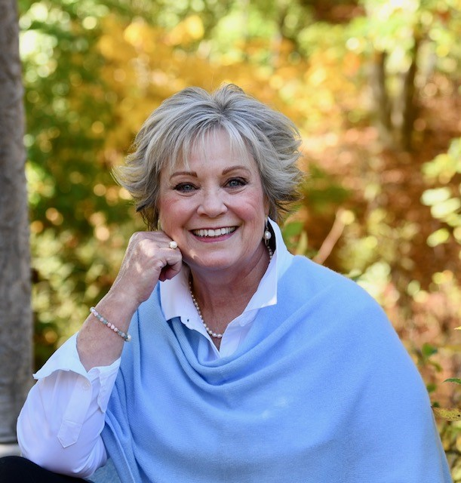

Constance Hays Matsumoto
203 Greenock Drive
Greenville, DE 19807
www.matsumotobooks.com
constancematsumoto@gmail.com | 410-804-1696

Published Works

Of White Ashes, a debut historical novel, inspired by the true events experienced by two American civilians of Japanese ancestry determined to live their birthright—the American dream. Loyola University Maryland Apprentice House Press, May 2023.

Links to other published works available at www.matsumotobooks.com

Memberships

Authors Guild
Eastern Shore Writers Association
Historical Novel Society
Maryland Writers’ Association
Women’s National Book Association

Education
Workshops/Conferences:  Association of Writers and Writing Programs (AWP) Conference, 2020, 2021  Historical Novel Society Conference, 2021, 2023  Maryland Writers’ Association Conference, 2021, 2022  Bay to Ocean Conference, 2021, 2022  Chesapeake Writers Workshop, 2019  The Writer's Center: Publish Now, 2019  Donald Maass: The Emotional Craft of Fiction, 2019  Community College of Baltimore County:  Writing Advanced Fiction Coursework | Notre Dame of Maryland University  B.A. Business Management, 1994  summa cum laude  The Johns Hopkins University  M.S. Business, 1998

Volunteer Experience

Maryland Writers’ Association (Board of Directors and Communications Chair; Past-Baltimore Chapter President; Conference Committee) 2020 – January 2023
Camp Sunrise (Board of Directors and Gala Decorating Chair) 2017 – 2022
Notre Dame of Maryland University (Officer-Alumnae and Alumni Council, Leadership Coach, and First Impressions Committee) 2011 – 2018
Maryland Senior Resource Network (Board of Directors) 2014 - 2016
Alzheimer’s Association (Memory Ball Gala Committee) 2014 – 2015
LitWorld (Board of Directors) 2007 – 2008
National Federation of the Blind (Research & Training Institute Advisory Board) 2002-2004
(Community Partnership Board) 2001-2004
Women Entrepreneurs of Baltimore (Board of Directors) 1999-2002

Constance Hays Matsumoto
Page two

Teaching Experience

Associate Faculty, Notre Dame of Maryland University 2000-2004
Prepared learners to be leaders by teaching graduate level business and HR management courses.

Business Experience

Pabríque Interior Design  Owner | 2009 - 2017

Provided full service interior design services: color consulting, furniture and lighting selection, paint and decorative finishes, custom window fashions, and accessories. Designs publicly displayed at the prestigious Long Island show house, Mill Neck Manor 2010 Designer Showcase, Mill Neck, NY, and Glynallyn, the 2012 Mansion in May show house in Morristown, NJ.

Women’s Leadership Institute  Owner | 1999 – 2009
Provided consulting and highly individualized coaching services to business professionals, diverse organizations, and the executives leading those organizations. Coached to reach higher levels of performance, meet current and future business and job challenges, and develop business and leadership competence. Extensive experience in assessment, strategic and developmental planning, process improvement, and helping organizations and people overcome obstacles, leverage strengths, and achieve goals aligned with their organization.

Zurich Insurance, Inc.  Director, Organizational Development and  Interim Lead of HR (1999) | 1996 - 1999
Directed the organizational development function for this $1 billion commercial insurance organization of 2,500 employees. Provided consultative and strategic support to senior staff at headquarters and 18 U.S. locations. Served as interim lead of human resources and provided guidance as the company experienced turbulent leadership and structural changes repositioning its U.S. market presence.

EA Engineering, Science and Technology, Inc.  Director, Human Resources | 1995 - 1996

CSX Intermodal, Inc. | 1988 - 1995
Promoted from Executive Assistant to Business Analyst to Human Resources Manager

