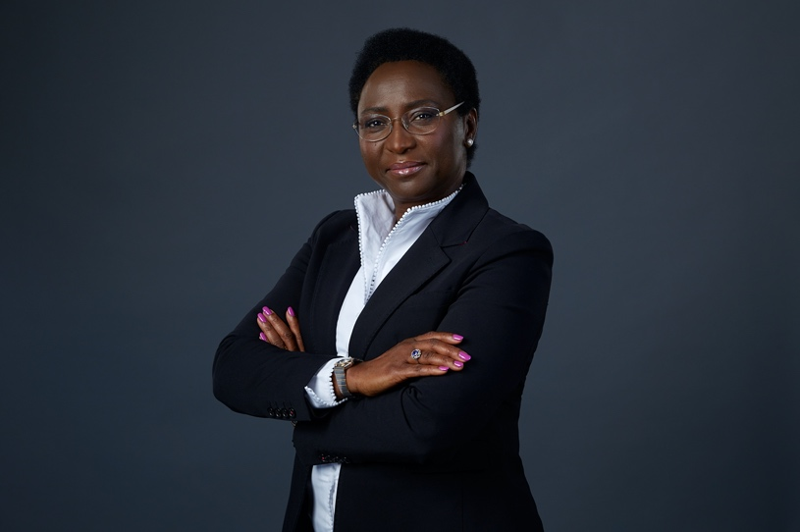

IRENE OCHEM

Listed as one of Nigeria’s 100 Most Inspiring Women, Irene Ochem is Founder and Chief Executive Officer of Africa Women Innovation and Entrepreneurship Forum (AWIEF), an award-winning, pan-African organisation dedicated to fostering women’s economic inclusion and empowerment through entrepreneurship support and development. AWIEF has Special Consultative Status with the United Nations Economic and Social Council (ECOSOC). AWIEF is a continental platform for driving inclusive economic transformation for women and works to close the gender gaps in entrepreneurship and innovation in Africa.

Ms Ochem is an entrepreneurship, trade, and innovation specialist, and holds an MBA from University of London and a Professional Doctorate in Global Leadership & Management from European International University, Paris. Her professional interest is focused on gender economic equity and social inclusion. She has 30+ years’ experience working across geographies of Africa and Europe in international development, research administration management, enterprise development, and private sector growth.

Her work at the strategic leadership of AWIEF is focused on driving female entrepreneurship, promoting enterprise and innovation, designing, deploying, and implementing bespoke women-centred business support and enterprise development solutions across different African countries, and mobilizing resources and partnerships. Her work has involved engaging with people at many different levels from startups and entrepreneurs to national governments, corporates, donor agencies and international development organisations.
Ms Ochem is the Founder and Convener of the prestigious annual AWIEF Conference and AWIEF Awards, Africa’s largest women entrepreneurship event launched in 2015 in Lagos. The AWIEF Conference is an international gathering of African and global entrepreneurship ecosystem stakeholders and partners, for dialogue and discussions on issues of women economic empowerment, entrepreneurship, policy, investing, innovation, and technology in Africa.
Ms Ochem has a proven track record building Africa’s foremost women entrepreneurship platform. Under her leadership, AWIEF has directly supported 5000+ startups and entrepreneurs across different African countries with diverse business support and entrepreneurship capacity development programmes. Indirectly she has reached millions through AWIEF’s different initiatives.

She has provided inputs to regional trade agreements on women economic empowerment, diversity, and inclusion. She serves on Boards as Non-Executive Director.

Ms Ochem is internationally known for her impactful work in area of women’s economic empowerment and entrepreneurship and has received reputable recognitions and awards.
She writes, speaks, and participates widely in high-level international dialogues, meetings and conferences on business, entrepreneurship, trade, women, and gender.

She has been featured in prestigious national and international media platforms including CNN and BBC.

