Nous vous encourageons à inviter le plus grand nombre possible de personnes à ce webinaire opportun
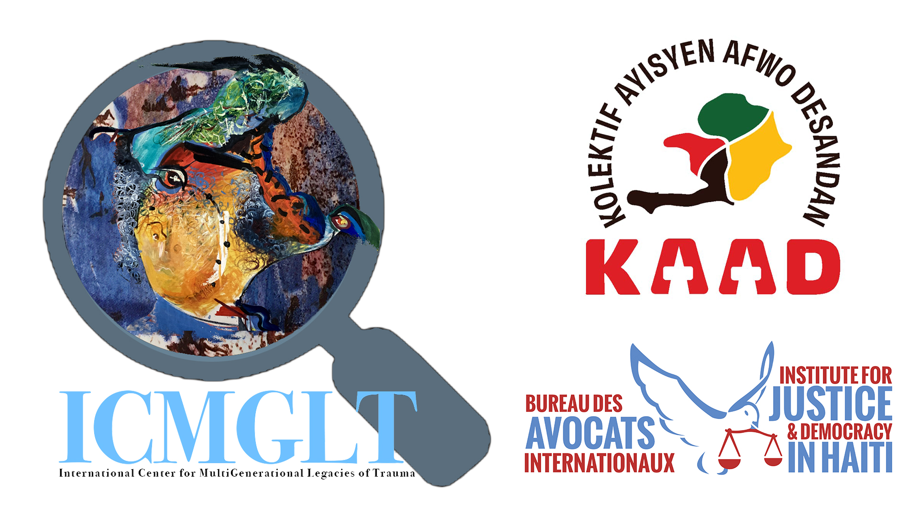
Dévoiler l’Héritage : Réflexions Académiques sur la Double Dette d’Haïti de 1825

Webinaire

Lundi 15 septembre 2025, 13h00-15h00 EDT / 13h00–15h00 Haïti / 10h00-12h00 PDT / 11h00-13h00 MDT / 17h00-19h00 GMT / 18h00-20h00 BST / 19h00-21h00 CAT & CEST / 20h00-22h00 EAT, EEST & IDT

Ce webinaire du Centre International pour les Héritages Multigénérationnels de Traumatismes, organisé en collaboration avec le Kolektif Ayisyen Afwo-Desandan (Collectif des Afro-Descendants Haïtiens), la Clinique de Justice Globale de l’École de Droit de NYU, l’Institut pour la Justice et la Démocratie en Haïti, et le Centre Anacaona des Droits Humains (France–Haïti), présentera un panel distingué de chercheurs multidisciplinaires d’origine haïtienne, spécialisés en histoire, sociologie, économie et droit. Ils s’engageront dans un discours critique et historiquement ancré sur l’indemnité de 1825, communément appelée la « double dette » (une charge financière imposée par la France pour indemniser les anciens colons et reconnaître l’indépendance d’Haïti), qu’Haïti a été contrainte de payer à la France.
Le panel d’experts examinera les ramifications durables et multiformes de cette dette sur les structures économiques, la souveraineté politique et le tissu social d’Haïti. De plus, il contribuera aux dialogues nuancés et en cours sur les dimensions historiques et contemporaines des réparations et de la guérison sociale, dans le contexte plus large de la justice pour le peuple haïtien et ses descendants à travers le monde.
Une interprétation simultanée sera disponible en anglais et en créole haïtien.
Intervenants:

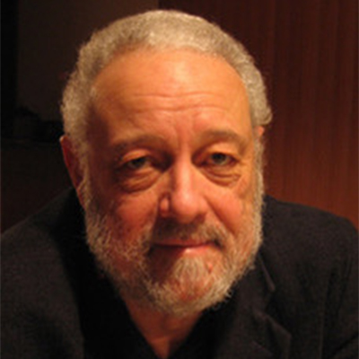

Dr. Alex Dupuy

Alex Dupuy is John E. Andrus Professor of Sociology Emeritus at Wesleyan University in Middletown, CT. An internationally recognized specialist on Haiti, he has lectured across the United States and abroad, has given interviews on local, national, and international radio and television networks, published more than three dozen articles in professional journals and anthologies, and six books, most recently Haiti Since 1804: Critical Perspectives on Class, Power, and Gender.

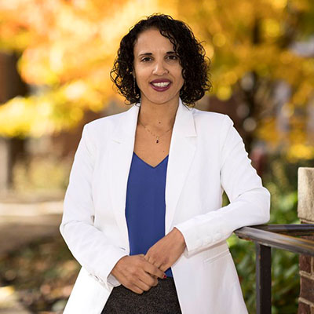

Professor Marlene L. Daut

A Professor of French, Black Studies, and History at Yale University. Most recently, she has authored The First and Last King of Haiti: The Rise and Fall of Henry Christophe. Previously, she authored Awakening the Ashes: An Intellectual History of the Haitian Revolution, which co-won the Frederick Douglass Book Prize.

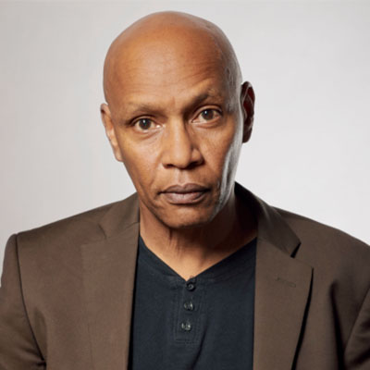

Dr. Jean Marie Théodat

A geographer and professor at the University of Paris 1 Panthéon-Sorbonne and the State University of Haiti. Holding a doctorate in geography, his research explores economic and cultural spaces, globalization, geopolitics, and regional studies of the Antilles, Caribbean, Haiti, and the Dominican Republic, with a focus on slavery, colonization, borders, and creolization.

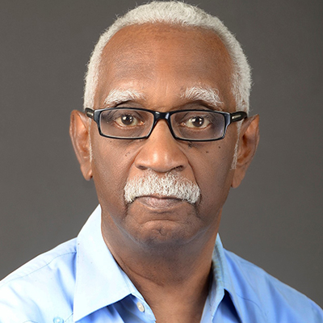

Professor Jean Casimir

Professor at the Faculty of Human Sciences at the State University of Haiti with a doctorate in sociology from the National Autonomous University of Mexico, he served as an official at the Economic Commission for Latin America and the Caribbean (1975-1988), and as Haiti’s Ambassador to the United States and Permanent Representative to the Organization of American States (1991–1997). His major works include The Oppressed Culture, The Caribbean, United and Divisible, and A Decolonial Reading of Haitian History.

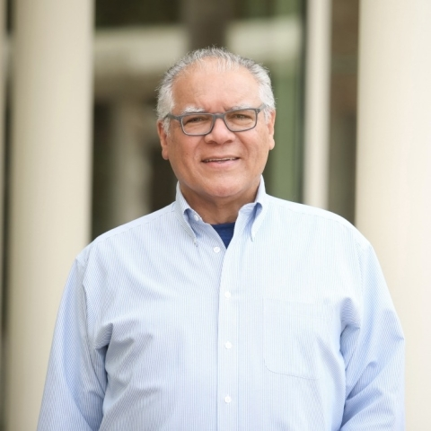

Professor Robert Fatton Jr.

Robert Fatton Jr. is Ambassador Henry J. Taylor and Mrs. Marion R. Taylor Emeritus Professor of Politics at the University of Virginia. He served as chair of the Department of Politics (1997-2004) and Associate Dean of the Graduate School (2010-2012). His numerous publications on Haiti include Haiti: Trapped in the Outer Periphery, and The Guise of Exceptionalism: Unmasking the National Narratives of Haiti and the United States. The Haitian Studies Association presented him its awards of Excellence, and of Lifetime Achievement.

Modérateurs:

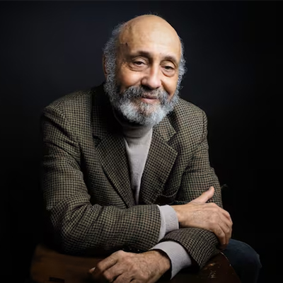

Frantz Voltaire

A Haitian scholar, filmmaker, and author who has taught at universities in Chile, Mexico, Haiti, and Canada. He has directed and produced acclaimed documentaries such as The Paths of Memory, Port-au-Prince, My City, Maestro Issa, and A History of Banking in Haiti. Founder of Éditions du Cidihca, he is widely recognized for his contributions to Caribbean history, culture, and diaspora studies.

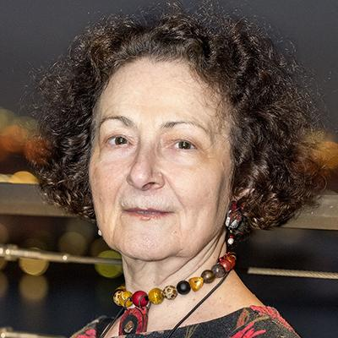

Dr. Yael Danieli
A Clinical psychologist, traumatologist, victimologist and psychohistorian, Dr. Danieli is Founder, Executive Director and Senior Representative to the United Nations of the International Center for MultiGenerational Legacies of Trauma (ICMGLT); Director, Group Project for Holocaust Survivors and their Children and Past-President, International Society for Traumatic Stress Studies.

