Nou ankouraje w envite plis moun posib nan webinè opòtin sa a
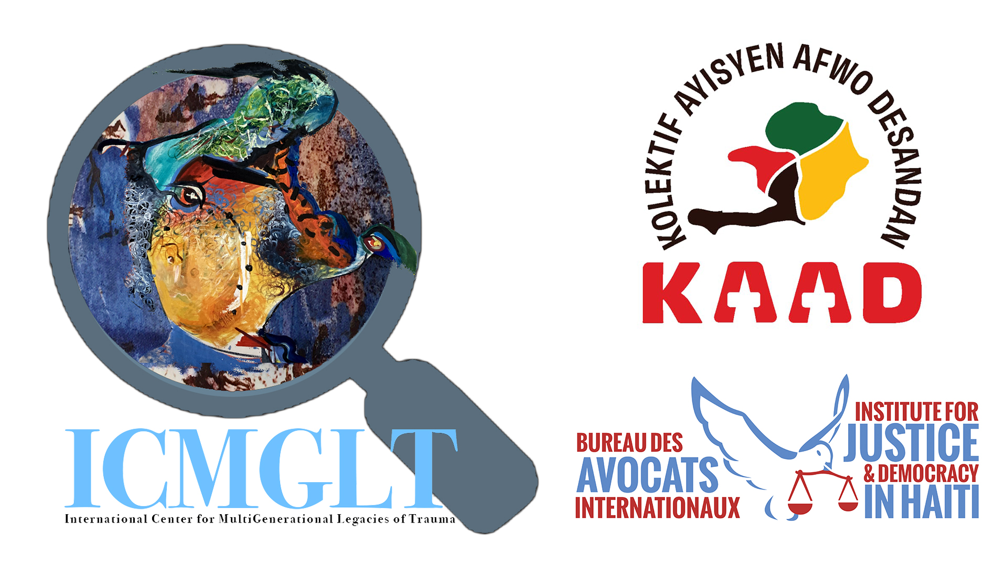
Devwale Erityaj la: Refleksyon Akademik sou Doub Dèt Ayiti an 1825

Webinè

Lendi 15 Septanm 2025, 1:00-3:00PM EDT / 1:00–3:00PM Ayiti / 10:00AM-12:00PM PDT / 11:00AM-1:00PM MDT / 5:00-7:00PM GMT / 6:00-8:00PM BST / 7:00-9:00PM CAT ak CEST / 8:00-10:00PM EAT, EEST ak IDT
Webinè Sant Entènasyonal pou Erityaj Milti-Jenerasyonèl nan Chòk sa a, ki fèt an kolaborasyon ak Kolektif Ayisyen Afwo-Desandan (Kolektif Afro-Desandan Ayisyen), Klinik Jistis Global Lekòl Lwa NYU, Enstiti pou Jistis ak Demokrasi an Ayiti, ak Sant Anacaona pou Dwa Moun (Lafrans–Ayiti), pral prezante yon panèl chèchè ayisyen espesyalize nan etid miltidisiplinè, tankou istwa, sosyoloji, ekonomi, ak dwa. Yo pral angaje yo nan yon diskou kritik ak istorikman fonde sou endemnite 1825 la, ke yo rele souvan « doub dèt la » (yon chaj finansye Lafrans te enpoze pou konpanse ansyen kolon yo e pou rekonèt endepandans Ayiti), ke Lafrans te fòse Ayiti peye.
Panèl ekspè sa a pral egzamine konsekans dirab ak plizyè aspè dèt sa a sou estrikti ekonomik, souverènte politik, ak twal sosyal Ayiti. Anplis, li pral kontribye nan dyalòg nuanse ki ap fèt kounye a sou dimansyon istorik ak kontanporen reparasyon ak gerizon sosyal, nan kontèks pi laj jistis pou pèp ayisyen an ak desandan yo atravè lemond.
Tradiksyon similtane ap disponib an anglè ak franse.

Entèvenan yo:

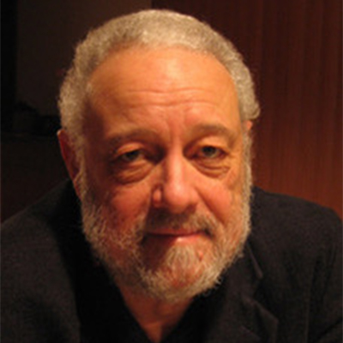

Dr. Alex Dupuy

Alex Dupuy is John E. Andrus Professor of Sociology Emeritus at Wesleyan University in Middletown, CT. An internationally recognized specialist on Haiti, he has lectured across the United States and abroad, has given interviews on local, national, and international radio and television networks, published more than three dozen articles in professional journals and anthologies, and six books, most recently Haiti Since 1804: Critical Perspectives on Class, Power, and Gender.

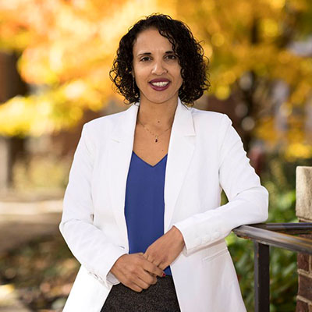

Professor Marlene L. Daut

A Professor of French, Black Studies, and History at Yale University. Most recently, she has authored The First and Last King of Haiti: The Rise and Fall of Henry Christophe. Previously, she authored Awakening the Ashes: An Intellectual History of the Haitian Revolution, which co-won the Frederick Douglass Book Prize.

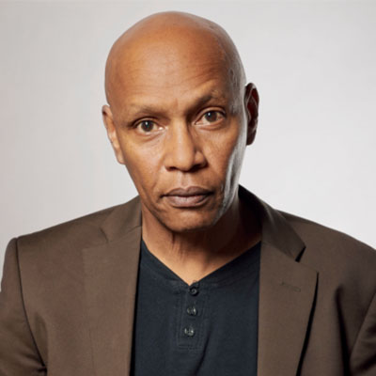

Dr. Jean Marie Théodat

A geographer and professor at the University of Paris 1 Panthéon-Sorbonne and the State University of Haiti. Holding a doctorate in geography, his research explores economic and cultural spaces, globalization, geopolitics, and regional studies of the Antilles, Caribbean, Haiti, and the Dominican Republic, with a focus on slavery, colonization, borders, and creolization.

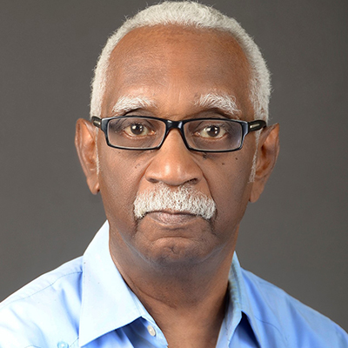

Professor Jean Casimir

Professor at the Faculty of Human Sciences at the State University of Haiti with a doctorate in sociology from the National Autonomous University of Mexico, he served as an official at the Economic Commission for Latin America and the Caribbean (1975-1988), and as Haiti’s Ambassador to the United States and Permanent Representative to the Organization of American States (1991–1997). His major works include The Oppressed Culture, The Caribbean, United and Divisible, and A Decolonial Reading of Haitian History.

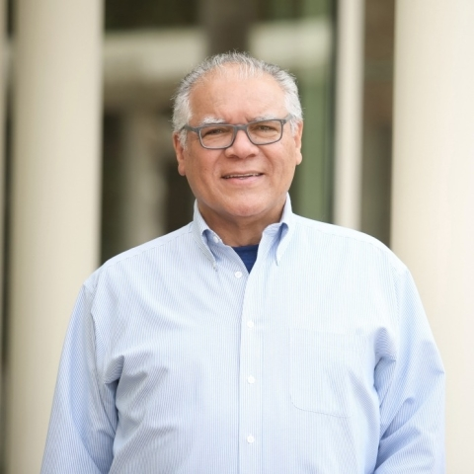

Professor Robert Fatton Jr.

Robert Fatton Jr. is Ambassador Henry J. Taylor and Mrs. Marion R. Taylor Emeritus Professor of Politics at the University of Virginia. He served as chair of the Department of Politics (1997-2004) and Associate Dean of the Graduate School (2010-2012). His numerous publications on Haiti include Haiti: Trapped in the Outer Periphery, and The Guise of Exceptionalism: Unmasking the National Narratives of Haiti and the United States. The Haitian Studies Association presented him its awards of Excellence, and of Lifetime Achievement.

Moderatè yo:

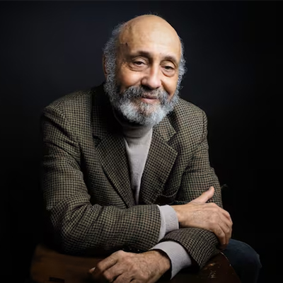

Frantz Voltaire

A Haitian scholar, filmmaker, and author who has taught at universities in Chile, Mexico, Haiti, and Canada. He has directed and produced acclaimed documentaries such as The Paths of Memory, Port-au-Prince, My City, Maestro Issa, and A History of Banking in Haiti. Founder of Éditions du Cidihca, he is widely recognized for his contributions to Caribbean history, culture, and diaspora studies.

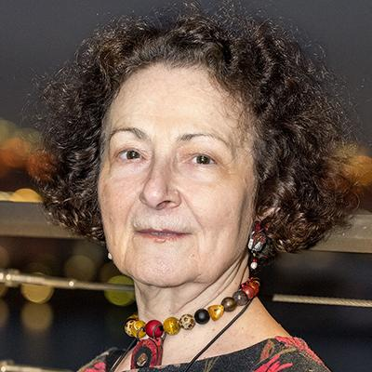

Dr. Yael Danieli
A Clinical psychologist, traumatologist, victimologist and psychohistorian, Dr. Danieli is Founder, Executive Director and Senior Representative to the United Nations of the International Center for MultiGenerational Legacies of Trauma (ICMGLT); Director, Group Project for Holocaust Survivors and their Children and Past-President, International Society for Traumatic Stress Studies.

