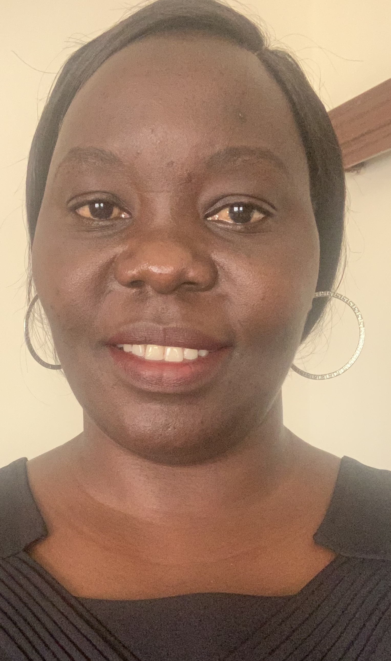
Ms. Jackline Nasiwa is a South Sudanese international lawyer, women’s rights advocate, and peacebuilding expert with over 15 years of experience promoting inclusive governance, justice, and civic participation in South Sudan. She is the Founder and Executive Director of the Centre for Inclusive Governance, Peace and Justice (CIGPJ), a national organization she established in October 2017 to advance gender inclusion, peacebuilding, transitional justice, access to justice, civic engagement, and survivor-centered advocacy in the country.
Ms. Nasiwa holds a Bachelor of Laws degree from Makerere University in Uganda and a Master’s degree in International Law with a specialization in International Law from Oxford Brookes University in the United Kingdom. Her professional work is driven by a strong commitment to human rights, gender justice, rule of law, accountability, and peacebuilding. She is a trained Peace Negotiator and Mediator at the Public International Law and Policy Group, UN and South Africa Department of International Relations and Corporation (DIRCO). Jackline's leadership in the civil society space, peace building and human rights activism is recognized couple with strong interpersonal and analytical skills. She is a trainer and facilitator with ability to to moderate dialogue and conflict resolution in complex political environments as seen in the successful stakeholder holders and grassroots dialogue in South Sudan.
Under her leadership, CIGPJ has contributed to significant milestones in strengthening civic space and women’s leadership in South Sudan. She played a key role in establishing several influential national advocacy platforms, including the Transitional Justice Working Group, the Women in Politics and Democracy Network, the Women’s Monthly Forum, and the first-ever Survivors Network of South Sudan—a groundbreaking initiative that amplifies the voices of survivors of conflict-related violence and advocates for justice, accountability, and reparations.

Under the leadership of Ms. Jackline Nasiwa, the Centre for Inclusive Governance, Peace and Justice (CIGPJ) has achieved significant milestones in advancing women’s leadership, justice, and civic participation in South Sudan. The organization successfully advocated for the inclusion of the 35% affirmative action quota for women in the Revitalized Agreement on the Resolution of the Conflict in the Republic of South Sudan (R-ARCSS), strengthening women’s representation in governance and peace processes. CIGPJ has mentored young women leaders through the Young Women Leaders Forum, supported 1,401 survivors of gender-based violence with legal aid and referral services through Community Centres for Responding to GBV, and facilitated the establishment of the Survivors Network of South Sudan to amplify survivor voices and advocate for justice and reparations. In addition, the organization promotes civic education and transitional justice through community dialogues, public forums, and media engagement, conducts research on women’s political participation and the implementation of the United Nations Security Council Resolution 1325 framework, and supports women’s economic empowerment by strengthening women-led businesses and Village Savings and Loan Associations across several states.

In addition to her leadership at CIGPJ, Ms. Nasiwa serves as the Deputy Chair of the Civil Society Forum in South Sudan, a platform that coordinates civil society engagement in national peace and governance processes. She also serves as the Chairperson of the Board of Directors of the National Alliance of Women Lawyers (NAWL), Crown the Woman Organization national organization providing legal aid and protection services to women and children in South Sudan.
Ms. Nasiwa has participated in numerous regional and international advocacy forums, including engagements with the United Nations Security Council and the African Union Commission, where she has advocated for the rights of South Sudanese women and girls and the inclusion of civil society voices in peace and justice processes. She is also recognized as a Senior Peace Fellow with the Public International Law and Policy Group, Women's Rights and Human Rights Awardee of 2021 by the South Sudan Women Intellectual Forum and Women Rights Defenders awardee of 2023 respectively.
Through her work, Ms. Nasiwa continues to champion inclusive governance, women’s leadership, and survivor-centered justice as essential pillars for sustainable peace and democratic development in South Sudan.

